## ***Design Patterns***

## **Factory**

Illustrating code Snippet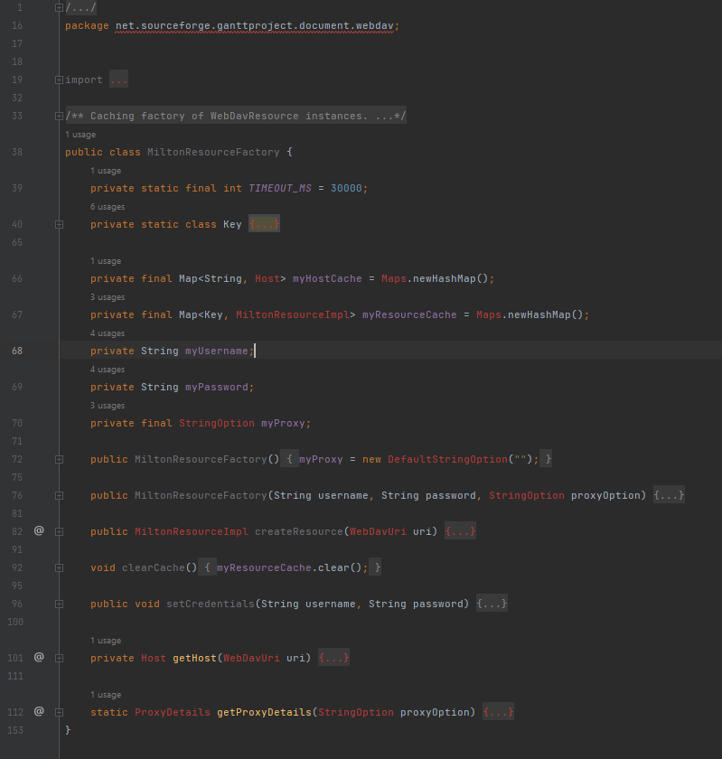

## **Class location:**

/[ganttproject](https://github.com/Gui28F/ganttproject/tree/master/ganttproject)/[src](https://github.com/Gui28F/ganttproject/tree/master/ganttproject/src)/[main](https://github.com/Gui28F/ganttproject/tree/master/ganttproject/src/main)/[java](https://github.com/Gui28F/ganttproject/tree/master/ganttproject/src/main/java)/[net](https://github.com/Gui28F/ganttproject/tree/master/ganttproject/src/main/java/net)/[sourceforge](https://github.com/Gui28F/ganttproject/tree/master/ganttproject/src/main/java/net/sourceforge)/[ganttproject](https://github.com/Gui28F/ganttproject/tree/master/ganttproject/src/main/java/net/sourceforge/ganttproject)/[document](https://github.com/Gui28F/ganttproject/tree/master/ganttproject/src/main/java/net/sourceforge/ganttproject/document)/[webdav](https://github.com/Gui28F/ganttproject/tree/master/ganttproject/src/main/java/net/sourceforge/ganttproject/document/webdav)/MiltonResourceFactory.java

## **Design pattern:**

Here we have a “Factory” design pattern that has the purpose to hide and simplify the creation of instances of MiltonResourceImpl.

## **Façade**

Illustrating code snippet

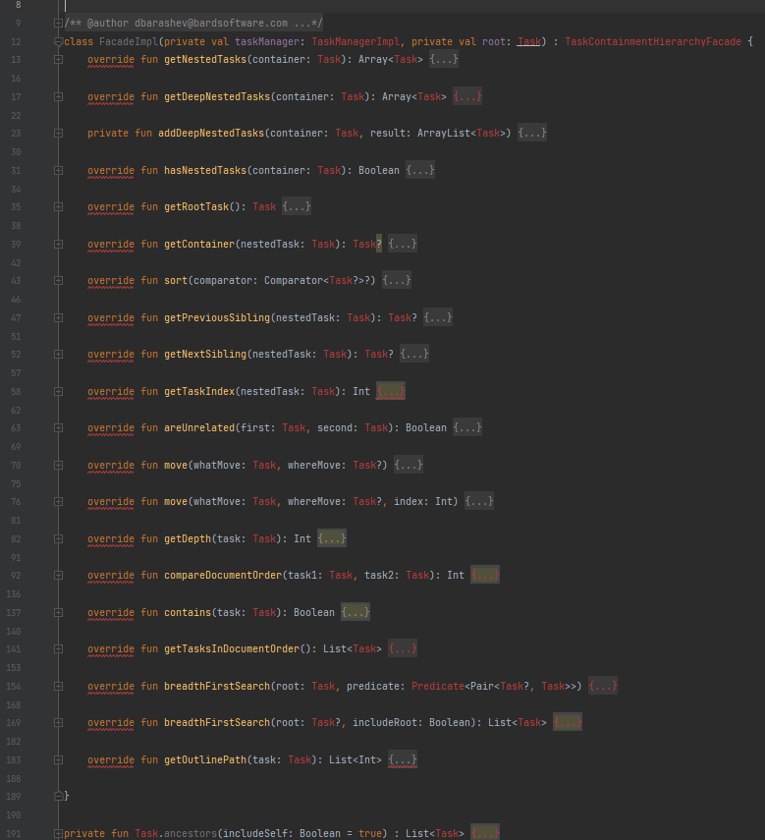

## **Class location:**

/[ganttproject](https://github.com/Gui28F/ganttproject/tree/master/ganttproject)/[src](https://github.com/Gui28F/ganttproject/tree/master/ganttproject/src)/[main](https://github.com/Gui28F/ganttproject/tree/master/ganttproject/src/main)/[java](https://github.com/Gui28F/ganttproject/tree/master/ganttproject/src/main/java)/[net](https://github.com/Gui28F/ganttproject/tree/master/ganttproject/src/main/java/net)/[sourceforge](https://github.com/Gui28F/ganttproject/tree/master/ganttproject/src/main/java/net/sourceforge)/[ganttproject](https://github.com/Gui28F/ganttproject/tree/master/ganttproject/src/main/java/net/sourceforge/ganttproject)/[task](https://github.com/Gui28F/ganttproject/tree/master/ganttproject/src/main/java/net/sourceforge/ganttproject/task)/TaskTreeFacade.kt

## **Design pattern:**

Here we have a “Façade” design pattern that encapsulates the whole Task tree hiding its complexity and making it easy to access the functionality of this subsystem.

## **Adapter**

Illustrating code snippet: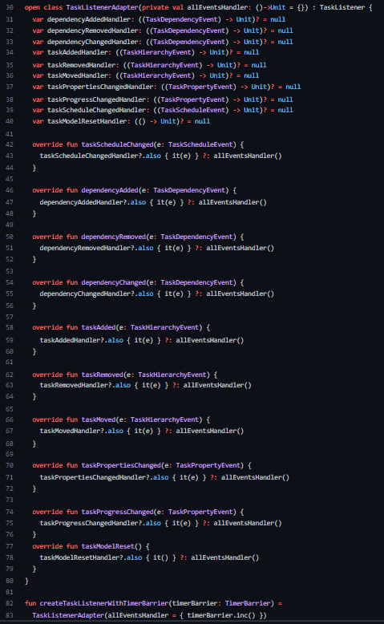

**Class location:**

/[ganttproject](https://github.com/Gui28F/ganttproject/tree/master/ganttproject)/[src](https://github.com/Gui28F/ganttproject/tree/master/ganttproject/src)/[main](https://github.com/Gui28F/ganttproject/tree/master/ganttproject/src/main)/[java](https://github.com/Gui28F/ganttproject/tree/master/ganttproject/src/main/java)/[net](https://github.com/Gui28F/ganttproject/tree/master/ganttproject/src/main/java/net)/[sourceforge](https://github.com/Gui28F/ganttproject/tree/master/ganttproject/src/main/java/net/sourceforge)/[ganttproject](https://github.com/Gui28F/ganttproject/tree/master/ganttproject/src/main/java/net/sourceforge/ganttproject)/[task](https://github.com/Gui28F/ganttproject/tree/master/ganttproject/src/main/java/net/sourceforge/ganttproject/task)/[event](https://github.com/Gui28F/ganttproject/tree/master/ganttproject/src/main/java/net/sourceforge/ganttproject/task/event)/

TaskListenerAdapter.kt

## **Design pattern:**

Here we have a “Adapter” design pattern which facilitates the handling of the events by delegating a single handler for all them and allowing two different classes that use different types of interfaces to communicate with each other.